**Ideation phase**

**Brainstorm & Idea Prioritization**

|  |  |
| --- | --- |
| **Date** | 30 September 2022 |
| **Team Id** | PNT2022TMID46985 |
| **Project Name** | PROJECT-5921-1658819999 |
| **Maximum Marks** | 4 Marks |

**Reference:**

**https://app.mural.co/t/applydatascience8285/m/applydatascience8285/1665926356085/6592c0a662a49c0e6265446c83d6b27bc0ee06d3?sender=u6f4a9272274a7fbe15a09641**

**Step-1: Team Gathering, Collaboration and Select the Problem Statement**

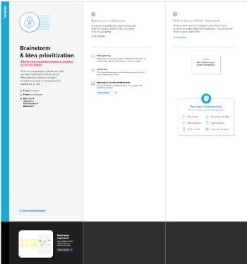

**Step-2: Brainstorm, Idea Listing and Grouping**

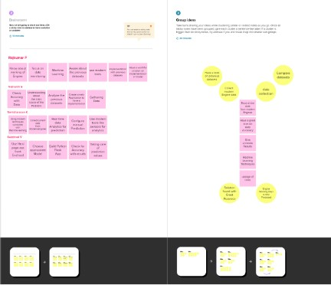

**Step-3: Idea Prioritization**

